The Harbor Line
A harbor park that protects Boston from flooding, generates cheap electricity and pays for itself
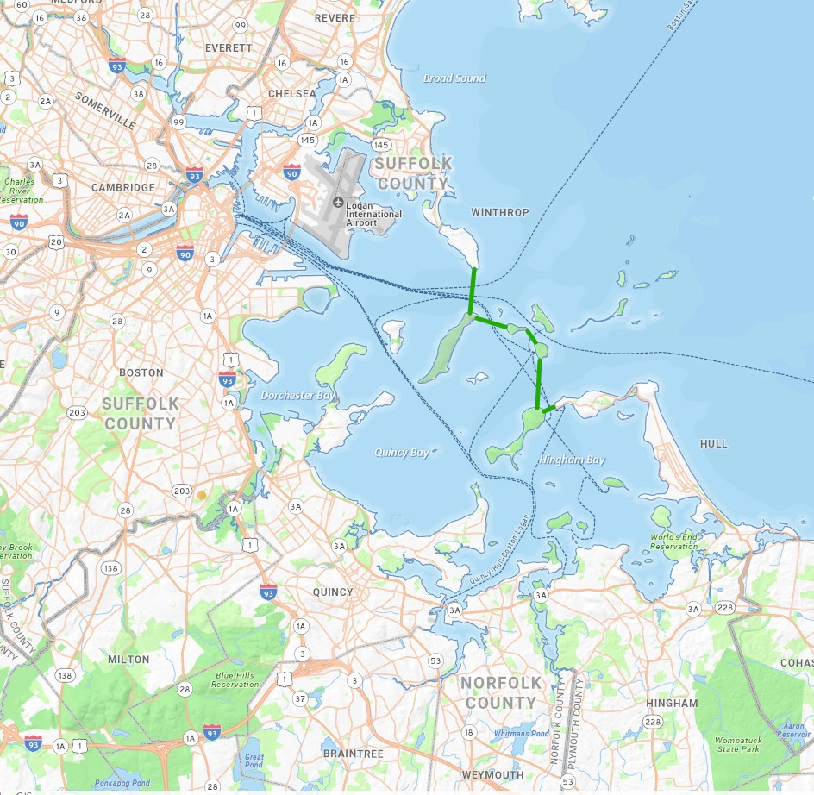
The Harbor Line is a four-mile tidal causeway that permanently protects all 21 harbor communities from flooding, lowers electric and gas-heating bills by generating enough cheap clean electricity to retire 2-4 gas-fired power stations, and provides walking access to the State and National Parks on the islands. The total cost is $4bn. The Harbor Line pays for itself through electricity sales, payments-in-lieu of flood insurance, and park concessions. It is viable today (it was not in 2018 when UMass studied it) because LNG tankers are no longer needed to supply the Mystic power plant in Everett because it closed in 2024. It creates good union jobs under Project-Labor Agreements.
What it is: A four-mile causeway — a solid land link topped by a wheelchair-accessible park trail — across the mouth of Boston Harbor, stepping from Deer Island over Long, Gallops, Georges, and Peddocks Islands to Hull. One structure does three jobs at once: it is the region’s flood shield, a clean-power plant, and a spectacular new waterfront park connecting the Harbor Islands. It removes the need for a new bridge from Quincy to Long Island.
The problem it solves: According to the U.S. Army Corps of Engineers, 284,000 Boston residents and 20,000 buildings are at risk of flooding. The risk of a hurricane-Sandy-level storm (which caused $19bn in damages to NYC) is over 90%. The Corps’ new plan would spend $9–10.5 billion on walls and gates through Boston to avoid $54bn in flood damage to only Boston. That work is important — but it protects only Boston, leaving neighbors like Winthrop, Revere, Chelsea, Everett, Cambridge, Somerville, Belmont, Logan Airport, all three harbor tunnels, Charlestown, Dorchester, Quincy, Braintree, Weymouth, Hingham, Cohasset and Hull to flood. The Harbor Line protects all these towns at half the cost of protecting only Boston. It is self-funding and it requires no new taxes.
How it protects: The causeway closes the harbor mouth against storm surges. Its ship gates stand open in normal weather and close only during a major storm — shielding all 21 cities and towns around the harbor at once.
How it pays for itself: Wind turbines along the causeway and tidal turbines inside it generate enough electricity for roughly one million homes. Selling that power — plus flood-protection fees that cost 25% less than flood insurance, park concessions from an expected 5–10 million annual visitors, and property taxes on new land at the ends — brings in about $410 million a year. The annual payment on the construction bonds is about $178 million. Income is more than double the payment, so the project needs no new taxes, in fact it generates a cash surplus of $200m a year. Building it costs $2.7–5.1 billion — best estimate $4 billion, less than half the Corps’ shoreline plan that protects only Boston and roughly what the UMass study estimated for the causeway in its proposal.
Why it’s possible now: For decades, giant liquified-natural-gas (LNG) tankers had to sail into the harbor under armed Coast Guard escort, and no structure across the shipping channel could be approved — the main reason a 2018 study (by UMass Boston) priced a harbor barrier with a giant moving gate at $8–12 billion and rejected it. That world has ended: the power plant those tankers supplied closed in 2024, only a few winter deliveries remain, and existing offshore terminals can receive those. The single biggest obstacle to a tidal-power causeway is gone.
The park: Four miles of scenic trail over the water — walking, biking, fishing, sailing, beaches, camping and wildlife, — that completes Olmsted’s Emerald Necklace of parks around the city. Vehicle access is limited.
What is being asked for now. The Legislature or DOER is asked to authorize a $15 million feasibility study, built on the UMass and USACE studies, of: the engineering, environmental, community and financial aspects to confirm whether the Harbor Line performs as projected, before any construction decision is made.
Full project briefing: The Harbor Line, with all calculations and data sources — download at greenzerocarbonhome.com — or from David Green at davidlcgreen@gmail.com. — USACE Suite v2 (July 2026)

